1.INTRODUCTION

1.1 OVERVIEW

Designing A Resume/CV Using Canva

1.2 PURPOSE

FOR SERCHING JOB

DEVLOP THE CREATIVE THING

2.PROBLEM DEFINATION AND DESIGN THINKING

2.1 EMPATHY MAP

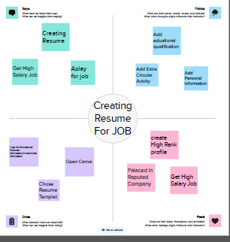

2.2 BRAIN STORM

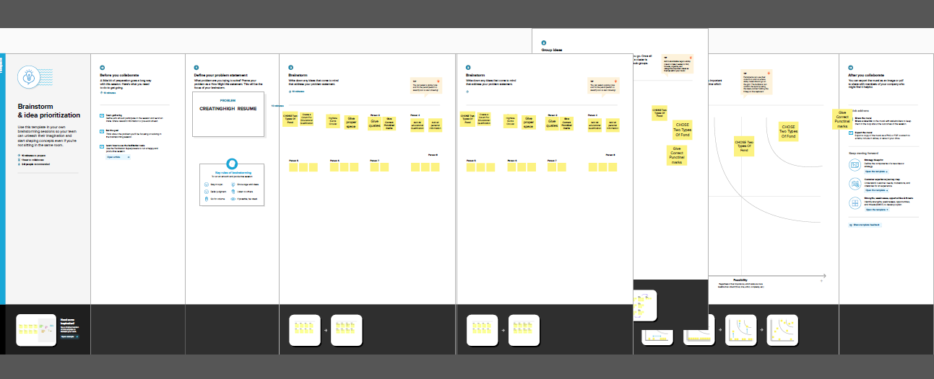

3.RESULT

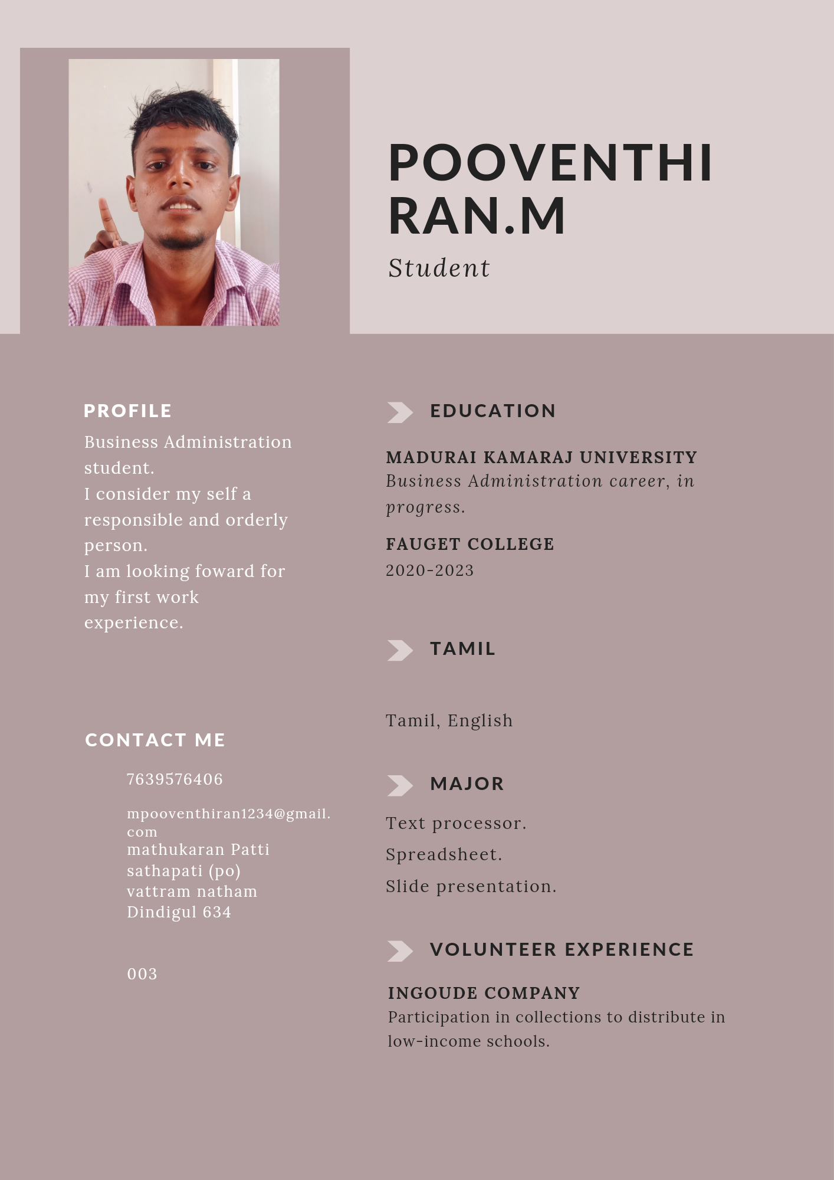

4.ADVANTAGES AND DISADVANTAGES

ADVANTAGES

EASYLE accessible

VERY CREATBLE DISADVAN TAGE

DISADVANTAGES

SOME designs ask money

5.APPLICATIONS

FOR SEARCHING JOB

TO GET HIGH RANGE SALARY

6.Conclusion

LEARN HOW TO MAKE A LOGO DESIGN.IT IS VERY USEFUL TO DEVLOP CREATIVE THING AND DESIGNING IDEAS